
Lesson 14 Teacher's Key: Raising the Stakes
001 Game Creator (Windows only) - Instructor Reference Only
VIDEO GAME CREATION

What This Lesson Teaches
This engine's version of difficulty scaling looks different from the other seven: since enemies are always pre-placed at design time (never runtime-spawned, per Lesson 5's precedent), 'more enemies per wave' means activating MORE pre-placed copies, not creating new ones - an honest, confirmed-mechanism-only approach given this engine's unverified runtime speed API.

Level 1 - Full Worked Solution
- enemy_6 and enemy_7 are added at design time, in the Map editor, as two more copies alongside the original enemy_1..enemy_5, spaced with the same full-enemy-width gap as the rest of the row - a direct continuation of Lesson 5's design-time-placement precedent.
- SpawnWave's nested If(wave >= 2) / If(wave >= 3) branches are what actually implements the scaling - each wave activates one more already-existing copy than the last, using only the confirmed Revive/Teleport mechanism from Lesson 11.
- ResetGame Destroying enemy_6/7 by default (before SpawnWave runs) is what keeps wave 1 looking exactly like Lesson 13's game - only 5 active copies until later waves need more.
Highlighted lines are new this week; everything else is code you already have.
Custom Event: SpawnWave (revised) ->
Actor – Destroy/Revive(Revive) + Teleport(enemy_1..enemy_5, starting positions)
If(wave >= 2)
Actor – Destroy/Revive(Revive) + Teleport(enemy_6, starting position)
If(wave >= 3)
Actor – Destroy/Revive(Revive) + Teleport(enemy_7, starting position)
Custom Event: ResetGame (revised) ->
Variable – Modify Value(wave, Set, 1)
Variable – Modify Value(enemies_remaining, Set, 4 + wave)
Actor – Destroy/Revive(Destroy) for enemy_6, enemy_7
Call Custom Event(SpawnWave)
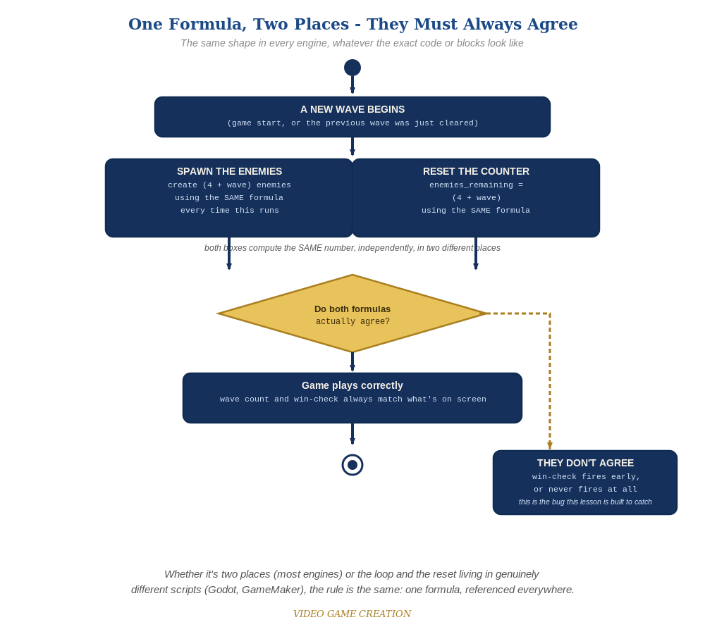
Whether the spawn loop and the reset live in two places or two genuinely different scripts, the rule is the same: one formula, referenced everywhere.

Why This Structure
- Rather than fabricate an unconfirmed 'set movement speed at runtime' action, this lesson leans entirely on mechanisms already verified in this course (Spawn/Destroy/Revive, design-time Actor placement) - the same honest-uncertainty approach used for this engine's restart flow in Lesson 10 and hit-flash timing in Lesson 13.
- This actually turns this engine's fixed-actor-count constraint into a genuine, different-but-valid solution to the same problem every other engine solves at runtime - worth presenting to students as a real design trade-off, not a lesser version of the 'real' approach.

Level 2 / Level 3 Talking Points
- Ask students on this engine to explain, in their own words, why 001 Game Creator's approach to more-enemies-per-wave is structurally different from every other engine this week, and why that's a reasonable consequence of a design decision made all the way back in Lesson 5.
- For advanced students: if their installed version DOES expose a runtime movement-speed action (check together), implementing per-wave speed scaling as a Level 3 stretch is a great extension, using the exact same wave-gated If-branch pattern as the count scaling.
Level 2 - complete code:
Level 2 is verification only for this engine - this engine's confirmed action set has no verified way to change Automatic Movement speed at runtime (see the Handout's Level 2 note), so there is no Level 2 code to add on top of Level 1.
Checks: play a full 3-wave round and confirm enemy_6 joins at wave 2 and enemy_7 joins at wave 3, with no copy left stuck mid-Destroy or appearing a wave early/late;
confirm restarting mid-game correctly Destroys enemy_6/7 again before SpawnWave re-revives only the wave-appropriate copies.
Level 3 - no single combined code example:
This week's Level 3 is a "choose ONE" menu of five independent stretch features (destructible shields, a power-up, a bonus enemy, formation-marching movement, or a title/game-over screen) rather than the usual set of small, combinable stretch goals - so a single "all goals combined" code block doesn't fit Rule 14's usual model, and isn't provided here. Full worked solutions for all five options, across the active engines, are planned for the Lesson 15 wrap-up "Complete Codebase" send-home materials instead. Use the Talking Points above and the Handout's Level 3 menu to guide students toward whichever option they choose.

Common Student Mistakes
- Forgetting to Destroy enemy_6/7 in ResetGame, leaving them visible on a fresh wave 1 game.
- Using If(wave = 2) instead of If(wave >= 2) for enemy_6, which would deactivate it again once wave 3 begins instead of keeping it active.
- Naming the new copies inconsistently (not exactly enemy_6/enemy_7), breaking SpawnWave's references to them.

